Chill!
you are on holiday
BEERS [ALC] Rs
Phoenix draft 275
Blue Marlin 275
Guinness Can 275
Manawa craft beer (IPA) 275
Heineken 0% 250

APERITIFS [ALC]
Porto 230

MAURITIAN RUM [ALC]
Local white rum 260
Local dark rum 260

VODKA [ALC]
Local Vodka 260

GIN [ALC]
Local Gin 260

BRANDY [ALC]
Local Brandy 260

WHISKY [ALC]
Local Whisky 270

DIGESTIFS [ALC]
Coffee cream 260

LIQUORS [ALC] 250
Mint
Coconut
Blackcurrant

HOT BEVERAGES
Coffee 160
Espresso 160
Cappuccino 170
Latte 170
Chocolate 195
Local Black or Green Tea 170
Detox green tea 170
Herbal Tea 170
(Mint, Chamomile, Verbena, Lime-blossom, Lemongrass)

ATTITUDE
SIGNATURE TEA 180
Vanilla and cardamom
Vanilla, passion fruit and mango

COFFEE COCKTAILS 315
Creole Coffee [ALC]
Brandy coffee [ALC]
Iced coffee 250

Rum 340
COCKTAILS
LOCAL RUM [ALC]
‘Inspiration of the day/ cocktail of the day’
Discover a new recipe inspired by the fresh products
of the day, refreshing & tasty, kindly ask your barman
the specialty of the day
Classic Mojito
White Rum, sugar cane syrup, fresh lime,
fresh mint leaves, topped up with sparkling
water, Angostura bitter
Pineapple Mojito
White Rum, sugar cane syrup, fresh lime juice,
fresh mint leaves, pineapple juice, topped up with
sparkling water
Passion fruit Mojito
White Rum, sugar cane syrup, fresh lime juice, fresh mint leaves, passion fruit juice, topped up with sparkling water
Dark and Spicy
Spiced Rum, sugar cane syrup, fresh lemon juice, sliced lemon, fresh mint leaves, sparkling water and Angostura bitter
Old Mauritian Rum
White Rum, brown sugar, orange peel, Angostura bitter
Fruit Chilled Daquiri
White Rum, sugar cane syrup, fresh lemon juice, fruit juice
Ti-Punch
White Rum, sugar cane syrup, fresh lime

CLASSIC COCKTAILS [ALC] 340
Planteur’s Punch
Dark Rum, White rum, pineapple juice, orange juice, Grenadine syrup and Angostura bitter
Pina Colada
White Rum, coconut liquor, pineapple juice, coconut milk, fresh cream
Mai Tai
Spiced Rum, pineapple juice, fresh lime juice, almond syrup, Angostura bitter

VODKA COCKTAILS [ALC] 340
Screw driver
Vodka, orange juice
Caipiroska
Vodka, sugar cane syrup, fresh lime juice

Blue Lagoon
Vodka, fresh lime juice, Blue Curacao, sparkling water

GIN COCKTAILS [ALC] 340
Gin Fizz
Gin, sugar cane syrup, fresh lime juice, sparkling water
Gimlet
Gin, sugar cane syrup, fresh lime juice
The Bramble
Gin, sugar cane syrup, fresh lime juice, pomegranate juice

WINE COCKTAILS [ALC] 340
Spritzer
White wine, sparkling water

WHISKY COCKTAILS [ALC] 350
Old Fashioned
Whisky, brown sugar, orange zest, angostura bitter
Whisky Sour
Whisky, fresh lime juice, sugar cane syrup

MOCKTAILS 300
Mocktail of the day
Ask the Barman about his signature of the day
Virgin Mango Colada
Mango juice, coconut milk, fresh cream
Virgin Mojito
Fresh mint leaves, fresh lime, sugar cane syrup,
sparkling water
Detox green tea
Green tea, ginger, lemongrass, lemon juice
Milkshake
Ice cream, milk, sugar cane syrup
Ask the barman the availability

FRIDAY 300
signature cocktail
Bor la mer
Coconut rum, Vanilla rum, Blue Curaçao

Happy Friday
Whisky, blackcurrent cream, pineapple juice, fresh cream

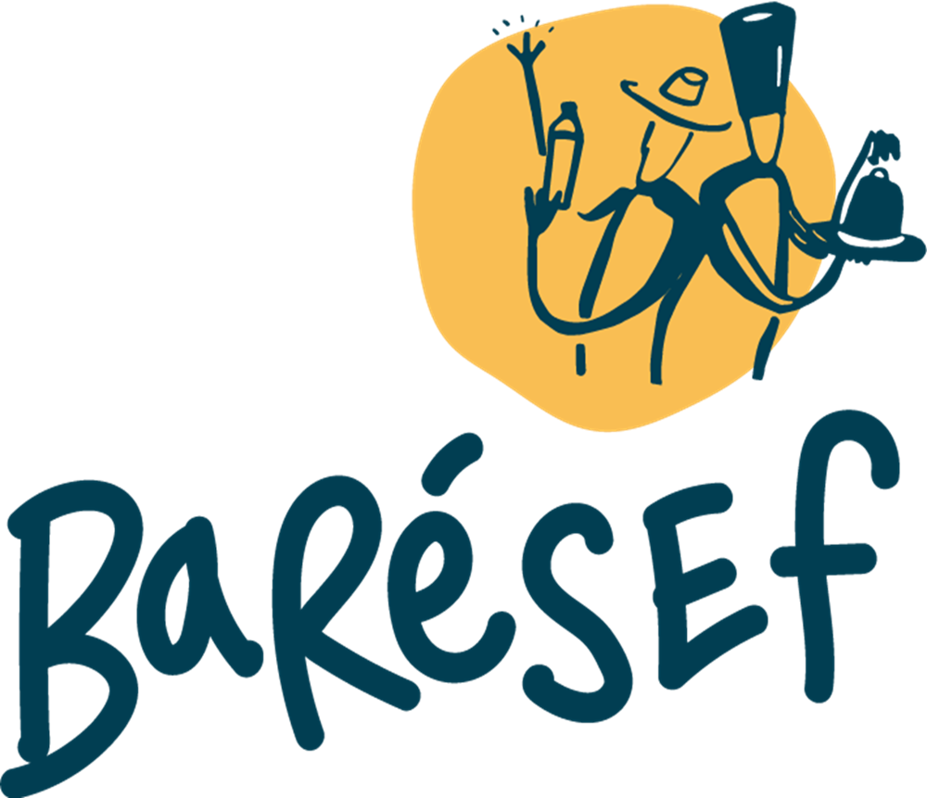

*Annual internal competition bringing together Attitude hotels’ best barman Cocktails on the list

BARESEF SIGNATURE COCKTAILS [ALC] 350
Kotomili Creation (2016)*
Vanilla Rum, pineapple juice, coriander,
lime juice, sugar cane syrup
Mo Lamem Creation (2018)*
Spiced Rum, lemon & watermelon juice, rosemary, sugar cane syrup
Mo Dite Creation (2019)*
Spiced Rum, grapefruit juice, vanilla black tea, sugar cane syrup, star anis
Tamam Sa Creation (2023)*
White rum, tamarind juice, passion fruit syrup, fresh lemon juice, star anis, caramelised orange slice.

BARESEF SIGNATURE MOCKTAILS 340
Zacoco Creation (2017)*
Coconut water, fresh mint leave, pineapple and lemon juice, sugar cane syrup, cardamom
Dilo Kokom Creation (2024)*
Fresh white cucumber juice, fresh green cucumber juice, fresh ginger, cardamon syrup, fresh lemon juice, basilic leaves, soda water.
Marose Creation (2024)*
Watermelon juice, fresh jicama juice, honey.
Sirop T. Creation (2024)*
Beetroot juice, carrot juice, fresh pineapple juice, coconut water, slice of ginger, honey
WATER 145
Still/ Sparkling

SOFT DRINKS 180
Coca Cola Coca-Cola diet
Sprite
Fanta
Tonic Water
Ginger Ale
FRUIT JUICES 180
Apple, Mango, Orange, Pineapple, Peach,
Lychee, Passion fruit, Grapefruit
on
supplement

BEERS [ALC]
Heineken 295
Savanna Dry 285

ENERGY DRINK 300
Red Bull

APERITIFS [ALC]
Campari 395
Pastis 395
Martini Rosso, Dry, Bianco 310

RUM [ALC]
Chamarel Vanilla 300
Chamarel Dark 300
Labourdonnais Amelia 300
Labourdonnais Spiced Gold 300
Green Island White 285
Green Island Spice Gold 285

VODKA [ALC]
Absolute 385
Smirnoff 300
KGB 300

GIN [ALC]
Bombay Sapphire 420
Gilbey`s 400
Gordon 400
Hendrick’ 420
Beefeater 400

BRANDY [ALC] 360
Napoleon

SCOTCH WHISKY [ALC] 395
J&B

PREMIUM WHISKY [ALC]
Chivas Regal - 12 years 450
Johnny Walker Red Label 415
Johnny Walker Black Label 450

SINGLE MALT [ALC]
Glenfiddich - 12 years 520
Ballantine’s 450

IRISH WHISKY [ALC] 380
Jameson

BOURBON WHISKEY [ALC] 380
Jim Beam White

SIGNATURE COCKTAIL[ALC] 395
Attitude Surprise
Bacardi rum, blue curacao, pineapple juice, lychee juice, fresh lime juice

COFFEE COCKTAIL [ALC] 395
Irish coffee
Jameson, coffee, sugar cane syrup, fresh cream

CLASSIC COCKTAILS [ALC] 395
Long Island Iced Tea
Vodka, gin, White Rum, Tequila, Triple sec,
fresh lemon juice and coke
Garibaldi
Campari and orange juice

VODKA COCKTAIL [ALC] 395
White Russian
Vodka, coffee liqueur, fresh cream

GIN COCKTAIL [ALC] 395
Summer G & T
Gin, fresh cucumber, fresh mint leaves, tonic water

CIGARETTE 630
Benson & Hedges
Dunhill
Marlboro red & Marlboro light
Camel & Camel light
Matinée 580

Please notify the bar manager should you have any allergens.
All prices are inclusive of 15% government tax and exclusive of 10% discretionary service tips.

Please notify the bar manager should you have any allergies.

